Graphs 4:
Edge-List: DFS and BFS

As we have mentioned before, a common task for graphs is to find the reachable vertices. This time we exhaustively traverse the edge-list representation, following the edges of each vertex until we reach an end or an already visited vertex.
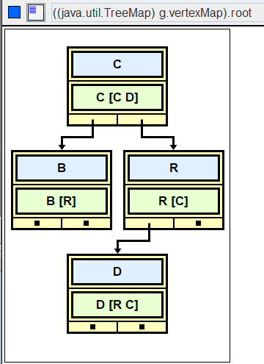
R
C
B
D
R | [C]
B | [R]
C | [C D]
D | [R C]

What can you reach from D? _________

Traversals come in two varieties, a depth-first search and a breadth-first search.
Depth-first search
A depth-first search traverses a graph and returns a string containing the names of the reachable vertices. The order in which the vertices are processed is determined by a stack.

In what order are the vertices visited, if Vertex D is the source?
B | [R]
C | [C D]
D | [R C]
R | [C]

first, create both a list of reachable vertices and a stack.
push D on the stack.
while the stack is not empty
pop a vertex. If the vertex isn't in the list, put it in the list.
warning: contains depends on hashCode and equals(Object)
process the vertex’s edges: push each vertex on the stack
concatenate the names in the list of reachable vertices.
return that string
Write the code:
public String depthFirstSearch(String name)
Breadth-first search
A breadth-first search also traverses a graph and returns a string of the names of reachable vertices. The order in which the vertices are processed is determined by a queue. The algorithm is the same, but use a queue instead of a stack, changing the appropriate method calls. You should be able to visualize why a stack produces a depth-first search and a queue produces a breadth-first search. You should know that the breadth-first search produces the shortest path, shortest in the sense of visiting the fewest vertices (or edges.)

In what order are the vertices visited, if Vertex D is the source?
B | [R]
C | [C D]
D | [R C]
R | [C]

first, create both a list of reachable vertices and a queue.
enqueue D’s adjacent vertices.
while the queue is not empty
dequeue a vertex. If the vertex isn't in the list, put it in the list.
warning: contains depends on hashCode and equals(Object)on the name
process the vertex’s edges: enqueue each adjacent vertex.
concatenate the names in the list of reachable vertices.
return that string
Two Typical Questions on Graphs
Consider this graph:
v0 <------- v2
/ \
/ \
-> v1 <-/ \-> v4
/ \
/ \
/ \->v3 -------> v5
/ /
/ /
v6 <---------/
- In what order are the vertices visited for a depth-first search (DFS) that starts at v0? (The neighboring edges are stored in alphabetic order.)

- In what order are the vertices visited for a breadth-first search (BFS) that starts at v0? (The neighboring edges are stored in alphabetic order.)

Assignment
In AdjList, comment in the DFS_BFS interface in the header and implement those two methods.

public class AdjList implements AdjListInterface, DFS_BFS//,EdgeListWithCities
Here is the DFS_BFS interface:

interface DFS_BFS
{
public String depthFirstSearch(String name);
public String breadthFirstSearch(String name);
/* extra credit */
// public String depthFirstRecur(String name);
// public List<Vertex> depthFirstRecurHelper(Vertex v, List<Vertex> reachable);
}

Sample Run (DFS_BFS_Driver.java using AdjList )
Edge List Representation!
B [R]
C [C D]
D [R C]
R [C]
Depth First Search
Enter source: B
Reachables: B R C D
Enter source: C
Reachables: C D R
Enter source: D
Reachables: D C R
Enter source: R
Reachables: R C D
Enter source: -1
Breadth First Search
Enter source: B
Reachables: B R C D
Enter source: C
Reachables: C D R
Enter source: D
Reachables: D R C
Enter source: R
Reachables: R C D
Enter source: -1
Set the debugger in AdjList to see the difference:
D ---> D C R
D ---> D R C

Extension
The iterative DFS algorithm above used a stack. Recursion also behaves like a stack, processing each method call in reverse. You have used this kind of recursion in previous labs: for every vertex you visit, process it, then recur (in reverse) on each of its edges. Return the string of the names of the reachable vertices.

